TASK 02
1. List 3 real-world devices in your home or college that use SMPS (Switched Mode Power Supply) and 2 devices that use UPS (Uninterruptible Power Supply), explaining in one line why each device needs that type of power supply.
1. Three devices that use SMPS (Switched Mode Power Supply)
No. | Device | Why it needs SMPS
1 | Desktop computer | Converts AC power into the different DC voltages required by computer components.
2 | Laptop charger | Converts AC power from the wall socket into suitable DC power to charge the laptop.
3 | LED TV | Converts AC power into the regulated DC voltages needed for its electronic circuits and display.

2. Two devices that use UPS (Uninterruptible Power Supply)
No. | Device | Why it needs UPS
1 | Desktop computer | Provides temporary backup power during a power cut, allowing the user to save work and shut down safely.
2 | Wi-Fi router | Keeps the internet connection working for a short time during a power outage.

2. Draw and label a diagram showing the main internal components of a typical SMPS unit found in a desktop PC, including AC input, rectifier, transformer, and DC output sections.<br><br><em><strong>Hint:</strong> You can hand-draw and upload a photo, or use any free diagram tool like draw.io.</em>.
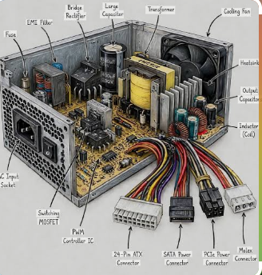
3. Take photos or find clear images online of the following power connectors: ATX 24-pin motherboard connector, SATA power connector, Molex connector, and PCIe 6/8-pin connector. For each, write its name, the devices it powers, and one safety tip for connecting/disconnecting it.
- ATX 24 - PIN MOTHERBOARD CONNECTOR
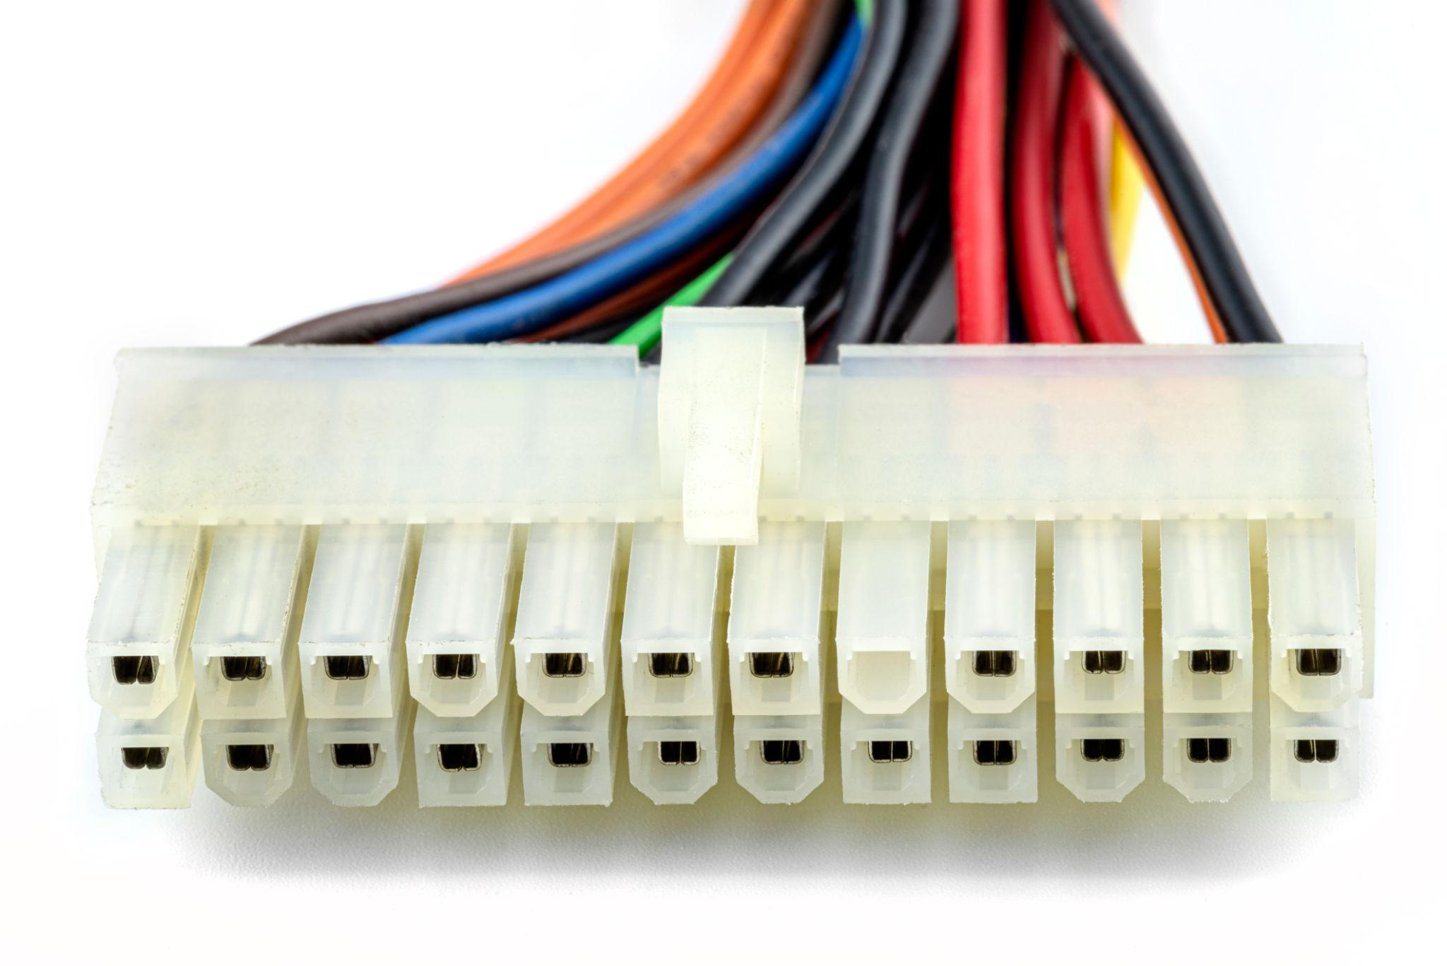
2. SATA power connector
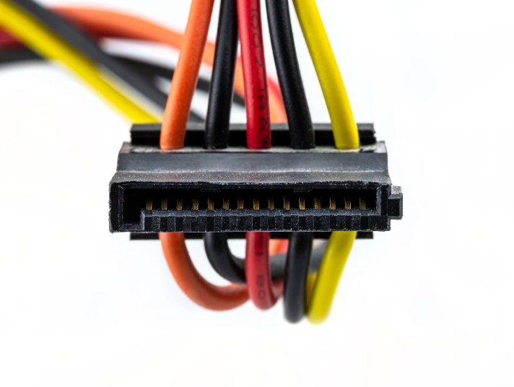
3. Molex 4-pin connector
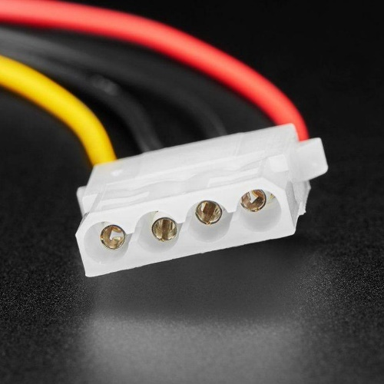
4. PCLe 6/8-pin connector
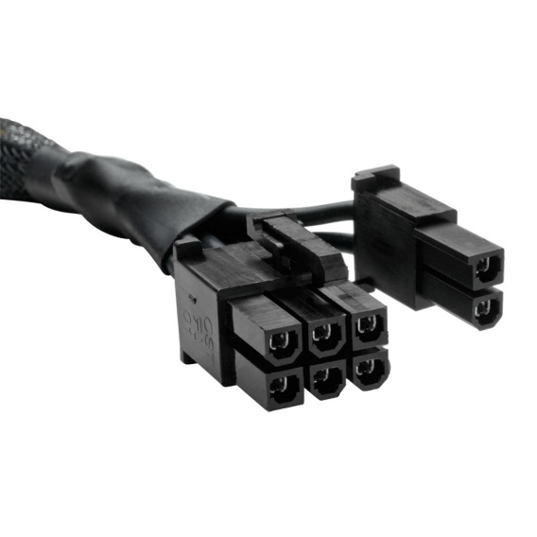

4.Imagine you are setting up a new gaming PC. List the steps you would follow to connect the SMPS to the motherboard, graphics card, and storage devices, mentioning which specific cables and connectors are used for each.
STEPS:
1. Switch off the power: Turn off the SMPS and unplug the power cord from the wall socket. Install the SMPS securely inside the PC case.
2. Connect the motherboard: Connect the 24-pin ATX power cable from the SMPS to the 24-pin motherboard power socket. This supplies the main power to the motherboard.
3. Connect the CPU: Connect the 4-pin or 8-pin EPS/CPU power cable to the CPU power socket near the processor. This supplies power to the CPU.
4. Connect the graphics card (GPU): Connect the required PCIe 6-pin, 8-pin (6+2-pin), or 12V-2x6 cable, depending on the graphics card. Ensure the connector is fully inserted and locked.
5. Connect the storage devices: Connect a 15-pin SATA power cable from the SMPS to each SATA HDD or SATA SSD. If using an M.2 NVMe SSD, it normally does not require a separate power cable because it receives power through the motherboard slot.
6. Connect other devices: If required, connect a 4-pin Molex power cable to compatible older fans or accessories.
7. Check all connections: Ensure every connector is secure, cables are clear of the fans, and no wires are pinched.
8. Start the PC: Close the case, reconnect the power cord, switch on the SMPS, and start the computer. Check that the system boots correctly.

